AWS Group Project Chapter 11 - Docker

Note: This project may be completed as an individual or as part of a group

Introduction: As senior engineers at Paradise Donut Company (PDC), you and your team are now well versed in the basic principles of modern software development and systems infrastructure. You know about code repositories, infrastructure as code, deployment pipelines, and now you know about docker containers. The company is new to docker containers, so you should practice with them in order to prepare for future software development.

The application: The application you are asked to build is a web page that lists a group of related items (donuts, favorite sports characters, favorite video game characters, Coca Cola beverage options--be creative and entertaining) with names and images (see an example below). The item-related information on the web page must be pulled from a database.

As you build this application, consider the infrastructure that would be needed for 31,000 retail locations.

The item list must come from a database (rather than be static content) because if these were items sold in retail stores, the selection would vary based on the needs/constraints of the individual store.

PDC envisions that this first iteration will be expanded into a full e-commerce website later, so you want to think about how you would smoothly push changes to code and infrastructure into production.

Using existing applications: If you want to use an application that you have worked on for another course or that is part of a personal or work project, you must create everything other than the code itself from scratch: the database, the infrastructure as code, the code pipeline, and the use of docker. It can’t be a submission of something that is already largely complete for the purposes of this project. You must be crystal clear on what existed before this current project, and what you added to it. If you didn’t do a comparable amount of work compared to other groups, you will be marked down.

Example of main page:
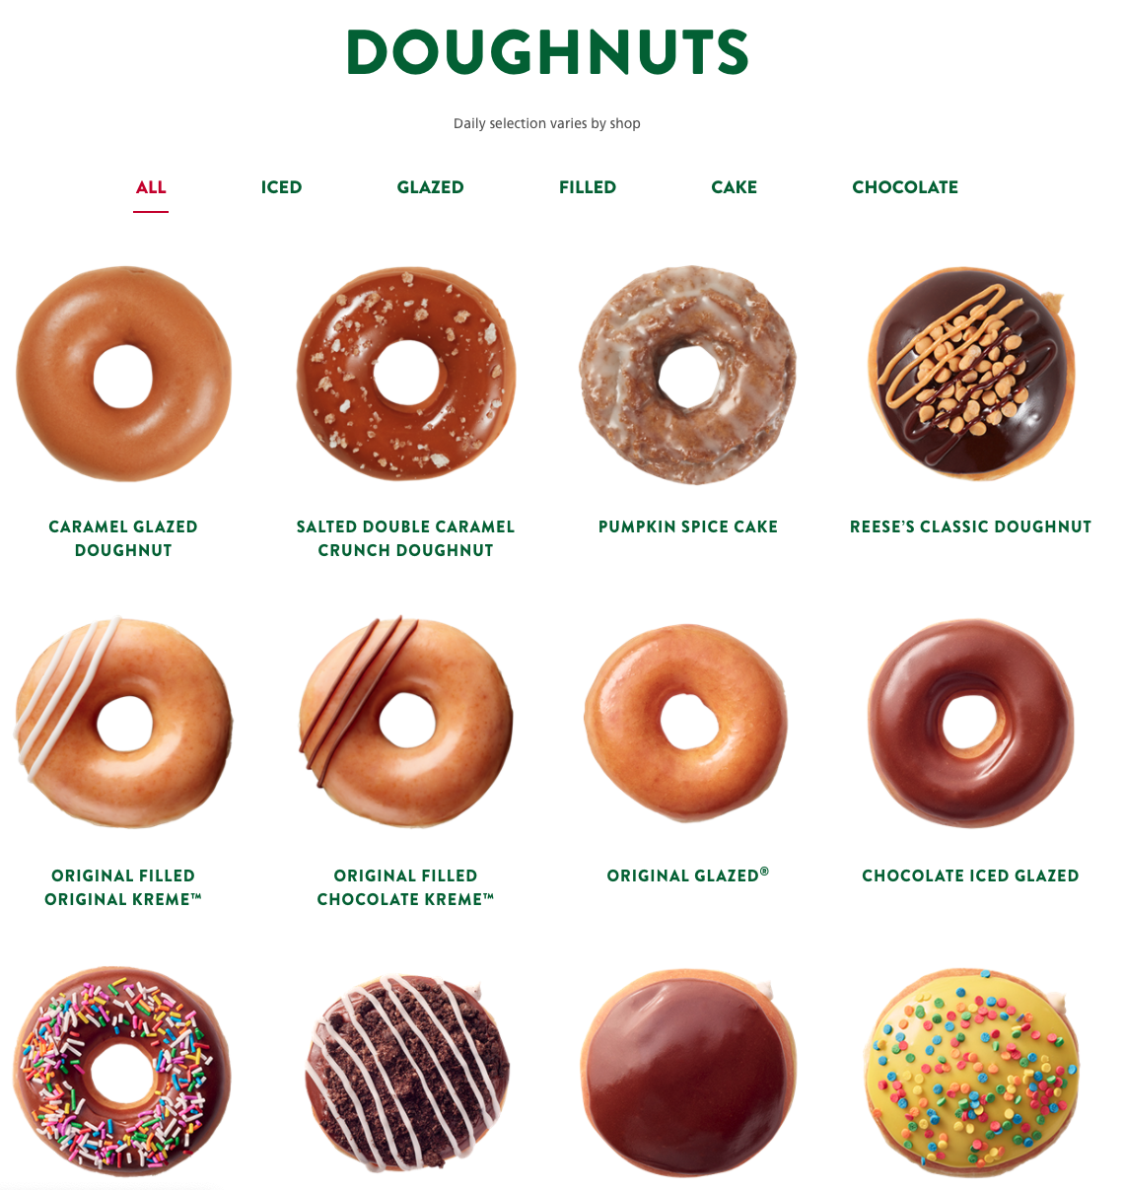

Requirements
Docker
Required for an A (93/100 points):
- Use Fargate to run your containers (50 points)
- Use RDS for Database (20 points)
- Create a yearly price estimate for running your infrastructure (explain your traffic assumptions (10 points)
- AWS Infrastructure Diagram. (10 points)
- Looks professional (3 points)

Additional Options:

- S3 bucket to host web assets such as html pages and images (1). Est 1-2 hours.
- The stack of resources for the application is created and updatable using Infrastructure as Code such (any flavor you wish) (2). Est. Up to 10 hours.
- The application will be supported by a Code Pipeline (or any other pipeline software you wish) (2) Est. Up to 5 hours.
- A language other than Node is used for the application (2). Est. up to 15 hours.

Rubric

100 points maximum are possible for this project, as follows:

Project 2 Features
Use Fargate to run your containers | /50
The database is run through AWS RDS | /20
Yearly price estimate to support millions of users | /10
AWS Infrastructure Diagram | /10
Looks professional | /3
S3 used to host web assets | /1
CloudFront used | /.25
Used programming language other than that shown in labs | /2
IaC used to build/maintain infrastructure | /2
A Code Pipeline supports the application | /2
Database is DynamoDB (will get points for the RDS option if you do this instead) | /1
A real URL is used with the load balancer | /.5
Other enhancements | TBD
Total | /100 (max)

Deliverables

To demonstrate completion of your project, fill out the Group Project Chapter 11 submission document and then upload the document.

Tips

- You can discuss your projects online or in person with other groups liberally, but you may not use (copy/paste) their code.

